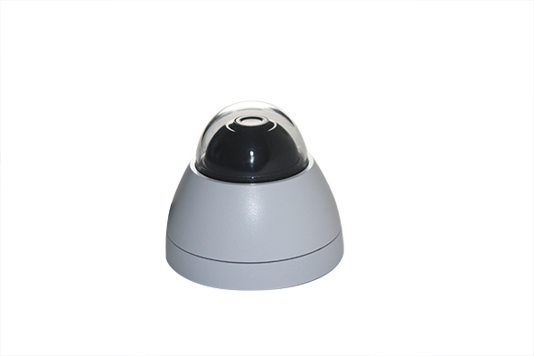

INDOOR DOME IP CAMERA

V1.1_20140711

User Manual



[Read More](Topics/Product%20Specifications.pdf)

[Read More](Topics/Warnings,%20Cautions%20and%20Copyright.pdf)

**I. Warnings, Cautions and Copyright**

**II. Product Specifications**

Product features, spec table and pictures.

Inside the folder ‘**Topics**’ you will find the documentation related with this IP Camera. You can click on ‘**Read More**’ for directly opening the file regarding the topic you would like to read.

Adobe Acrobat is recommended.

Topics

This is a 1 / 2.7” Mega-Pixel CMOS Sensor IP camera with a built-in web server. The user can view real-time video via IE browser. It supports H.264, and M-JPEG video compression, providing smooth and high video quality. The video can be stored in Micro SD card and playback remotely.

With a user friendly interface, it is an easy-to-use IP camera for security applications.

INDOOR DOME IP CAMERA



[Read More](Topics/Install%20ActiveX%20control.pdf)

[Read More](Topics/Monitor%20Settings.pdf)

[Read More](Topics/Hardware%20Installation.pdf)

[Read More](Topics/IP%20Assigment.pdf)

[Read More](Topics/System.pdf)

[Read More](Topics/Live%20Video.pdf)

**III. Product Installation**

**A. Monitor Settings**

Monitor Configuration

**B. Hardware Installation**

IP Camera Hardware Installation, Connectors, POE

**C. IP assignment**

IP Installer, Change IP address, Login

**D. Install ActiveX control**

ActiveX installation and troubleshooting

**IV. Live Video**

Live View interface functions

**V. Camera Configuration**

Configuration functions description

**A. System**

Language, User Management, System Update

INDOOR DOME IP CAMERA



[Read More](Topics/Network%20Configuration.pdf)

[Read More](Topics/Event%20List.pdf)

[Read More](Topics/AV%20Settings.pdf)

[Read More](Topics/IO%20configuration.pdf)

[Read More](Topics/Network.pdf)

**B. Network**

IP Settings, RTSP, ONVIF, Bonjour, LLTD,

HTTP & HTTPS, SNMP, Access List, QoS,

IEEE 802.1x, PPPoE & DDNS, FTP, SAMBA.

**C. A / V Settings**

Image Setting, Corridor Mode,

Video Setting, Resolution, Audio

**D. Event List**

Event Setting, Motion Detection,

Tampering Detection, Record Time Setting, Schedule, Log List, SD card playback & Management.

**VI. Network Configuration**

**VII. I / O Configuration**

I / O Configuration & Setup, Relay

INDOOR DOME IP CAMERA



[Read More](Topics/Universal%20Password.pdf)

[Read More](Topics/Micro%20SD%20Card%20Compatibility.pdf)

[Read More](Topics/Package%20Contents.pdf)

[Read More](Topics/Factory%20Default.pdf)

**VIII. Factory Default**

Steps for reset the IP Camera to factory default.

**IX. Universal Password**

Steps for using universal password.

**X. Package Contents**

**XI. Micro SD Card Compatibility**

List of Micro SD cards compatible with this IP Camera

INDOOR DOME IP CAMERA